BANK LOAN QUERY REPORT DOCUMENT
KPI’s (summary Dashboard)
- Total Loan Application
SELECT count(id) AS total_Loan_applications FROM bank_loan_data
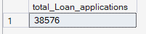

- Month to Date (MTD) Loan Application
SELECT count(id) AS MTD_Month_to_Date FROM bank_loan_data
where MONTH(issue_date)=12 and YEAR(issue_date)=2021
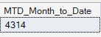
- Previous Month to Date (PMTD) Loan Application
SELECT COUNT(id) AS Previous_MTD_Loan_Applications FROM bank_loan_data
WHERE MONTH(issue_date)=11 and YEAR(issue_date)=2021
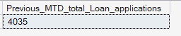
- Total Funded Amount
SELECT SUM(loan_amount) AS Total_funded_amount FROM bank_loan_data
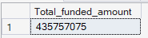
- MTD of Total Funded Amount
SELECT SUM(loan_amount) AS MTD_Total_funded_amount FROM bank_loan_data
WHERE MONTH(issue_date) = 12 AND YEAR(issue_date)= 2021
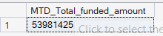
- Previous MTD of Total Funded Amount
SELECT SUM(loan_amount) AS PMTD_Total_funded_amount FROM bank_loan_data
WHERE MONTH(issue_date)=11 AND Year(issue_date)=2021
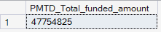
- Total Amount Received Back
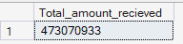

- MTD of Total Amount Received
SELECT SUM(total_payment) AS MTD_Total_amount_recieved FROM bank_loan_data
WHERE MONTH(issue_date)=12 and YEAR(issue_date)=2021
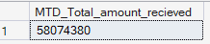
- Previous MTD of total amount received
SELECT SUM(total_payment) AS PMTD_Total_amount_recieved FROM bank_loan_data
WHERE MONTH(issue_date)=11 and YEAR(issue_date)=2021

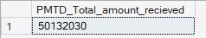
- Avrage Intrest Rate
SELECT ROUND(AVG(int_rate)*100,2) AS Average_Interest_Rate From bank_loan_data
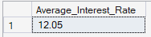
- MTD of Avg Intrest Rate
SELECT ROUND(AVG(int_rate)*100,2) AS MTD_Average_Interest_Rate From bank_loan_data
WHERE MONTH(issue_date)=12 and Year(issue_date)=2021
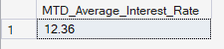
- PMTD of Avg Intrest Rate
SELECT ROUND(AVG(int_rate)*100,2) AS PMTD_Average_Interest_Rate From bank_loan_data
WHERE MONTH(issue_date)=11 and Year(issue_date)=2021
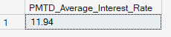
- Average DTI (Debt to income ratio)
SELECT Round(AVG(dti)*100,2) AS Avg_DTI_Score From bank_loan_data
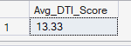
- MTD of Avg DTI
SELECT Round(AVG(dti)*100,2) AS Avg_DTI_Score From bank_loan_data
WHERE MONTH(issue_date)=12 and YEAR(issue_date)=2021
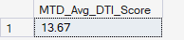
- PMTD of Avg DTI
SELECT Round(AVG(dti)*100,2) AS PMTD_Avg_DTI_Score From bank_loan_data
WHERE MONTH(issue_date)=11 and YEAR(issue_date)=2021
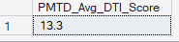

DASHBOARD 1 : Summary
Good Loan & Bad Loan KPI
- Good Loan application percentage
SELECT
Round((COUNT(CASE
WHEN loan_status IN('Fully Paid','Current')
THEN id END)*100)
/
COUNT(id),2) AS Good_loan_percentage
FROM bank_loan_data
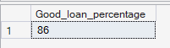
- No of Good Loan Apllication
SELECT COUNT(id) AS Good_Loan_application FROM bank_loan_data
WHERE loan_status IN ('Fully Paid','Current')
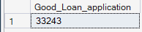
- Good Loan Funded Amount
SELECT SUM(loan_amount) AS Good_Loan_Funnded_Amount FROM bank_loan_data
WHERE loan_status IN ('Fully Paid','Current')
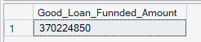
- Good Loan Amount Received
SELECT SUM(total_payment) AS Good_Loan_Funnded_Amount FROM bank_loan_data
WHERE loan_status IN ('Fully Paid','Current')

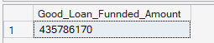
- Bad Loan Application Percentage
SELECT
((COUNT(CASE WHEN
loan_status ='Charged Off'
THEN id END)*100)
/
COUNT(id)) AS Bad_loan_Percentage
From bank_loan_data
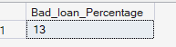
- Bad Loan Application
SELECT COUNT(id) As Bad_Loan_application from bank_loan_data Where loan_status='Charged Off'
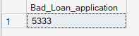
- Bad Loan Funded Amount
SELECT SUM(loan_amount) AS Bad_Loan_Funnded_Amount FROM bank_loan_data
WHERE loan_status ='Charged Off'
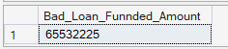

- Bad Loan Amount Recieved
SELECT SUM(total_payment) AS Bad_Loan_Amount_Recieved FROM bank_loan_data
WHERE loan_status ='Charged Off'
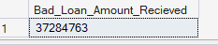
- Loan Grid Status
SELECT loan_status,
COUNT(id) AS Total_loan_application,
SUM(loan_amount) AS Total_Funded_amount,
SUM(total_payment) AS Total_amount_Recieved,
Avg(int_rate)*100 AS Avg_intrest_Rate,
AVG (dti) As DTI

FROM bank_loan_data
GROUP BY loan_status
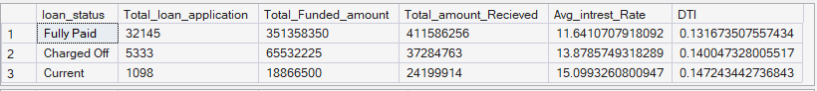
- Loan Grid MTD & PMTD Status group by loan status
SELECT loan_status,
Sum(loan_amount) As MTD_Funded_amount,
Sum(total_payment) As PMTD_Funded_amount
From bank_loan_data
Where MONTH(issue_date)=12 And Year(issue_date)=2021
Group By loan_status
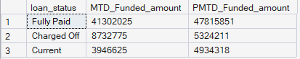
DASHBOARD 2: OVERVIEW
- Monthly trend by issue dates
SELECT
Month(issue_date)As Month_Num,
DATENAME(Month,issue_date) As Month,
count(id) as Total_loan_application,
Sum(loan_amount) as Total_funded_amount,
sum(total_payment) as Total_amount_recieved
from bank_loan_data
Group By Month(issue_date),DATENAME(Month,issue_date)
Order by Month(issue_date)
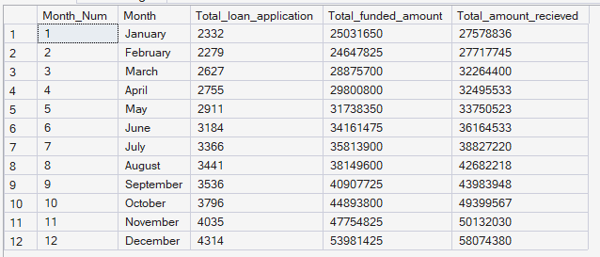

- Regional Analysis by State
SELECT
address_state,
count(id) as Total_loan_application,
Sum(loan_amount) AS Total_funded_amount,
Sum(total_payment) As Total_amount_recieved
from bank_loan_data
Group By address_state
order by Sum(loan_amount) desc

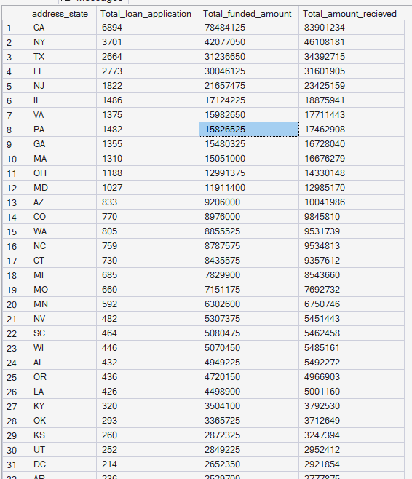

- Loan Term Analysis
SELECT
term,
count(id) as Total_loan_application,
Sum(loan_amount) AS Total_funded_amount,
Sum(total_payment) As Total_amount_recieved
from bank_loan_data
group by term
order by term
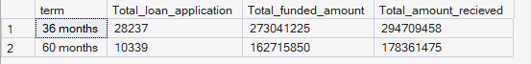
- Employee Length Analysis
SELECT
emp_length,
count(id) as Total_loan_application,
Sum(loan_amount) AS Total_funded_amount,
Sum(total_payment) As Total_amount_recieved
from bank_loan_data
group by emp_length
order by emp_length
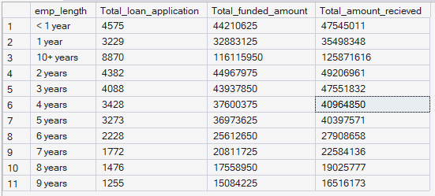
- Loan Purpose Breakdown
SELECT
purpose,
count(id) as Total_loan_application,
Sum(loan_amount) AS Total_funded_amount,
Sum(total_payment) As Total_amount_recieved
from bank_loan_data
group by purpose
order by Sum(loan_amount) desc
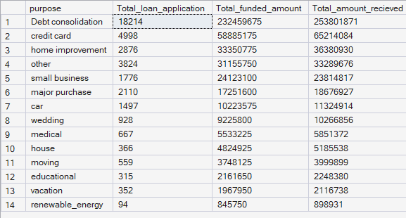
- Home Ownership Analysis
SELECT
home_ownership,
count(id) as Total_loan_application,
Sum(loan_amount) AS Total_funded_amount,
Sum(total_payment) As Total_amount_recieved
from bank_loan_data
group by home_ownership
order by Sum(loan_amount) desc
